Faultlines Rulebook
Created by: Charles + Peter + Kevin + Kyle + Sriveda
Special Thanks To: Mr. Tillotson

Introduction:
In this game, players or groups of players represent countries and their fleets in the South China Sea. Each country’s objective is to improve their position by the end of the game, and countries can do so by fishing for fish and controlling fishing zones. You must focus on keeping a stable fish population throughout the fishing zones and perhaps build alliances to protect the fish so everyone can profit. However, you must keep in mind that your goal is only to help yourself, build up your fleet and control the South China Sea.
Each year, there are four seasons which divide the game into sub-rounds for different activities:
Spring: Submit movement orders for ships and fishing boats
Summer: Conduct diplomacy and/or resolve combat
Fall: Submit and resolve fishing orders to gain resources
Winter: Purchase ships and build bases

The Map
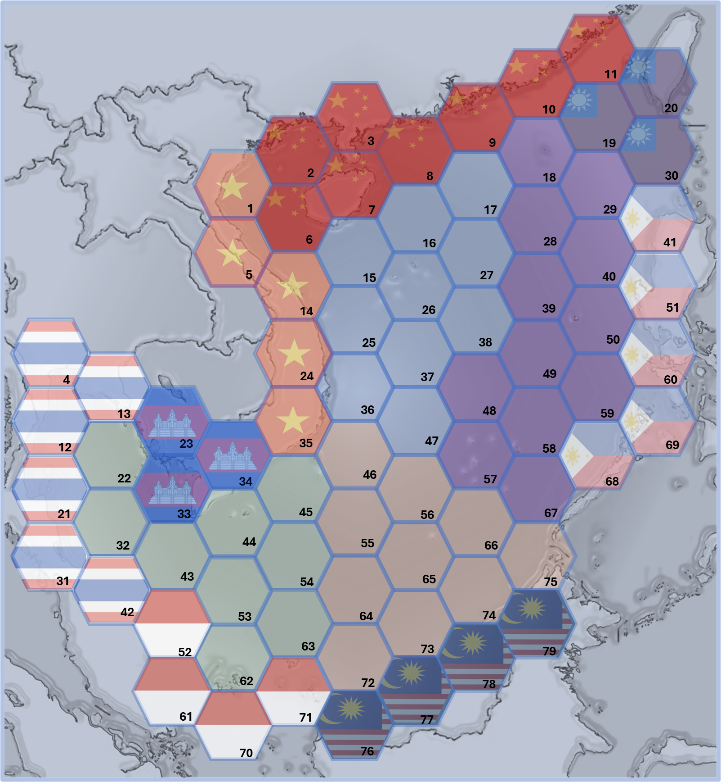

Fishing zones
In this game, there is a map that is divided into hexagons. Each hex tile has a number and is part of a larger fishing zone, colored representing a country’s fishing zone or a larger neutral zone. Each fishing zone has its own population and different limits to it, with the few central zones having much more fish, and the smaller country zones having much less. The smaller zones that are controlled by each country are called the Exclusive Economic Zone (EEZ), and each country must control their own zone to prevent others from fishing in it using coast guard units or other combat ships.

Details for each fishing zone
Below is the information for each fishing zone:
Zone | Carrying cap | Initial amount
China | 7 | 3
Taiwan | 4 | 2
Philippines | 6 | 2
Malaysia | 5 | 2
Indonesia | 5 | 3
Thailand | 6 | 3
Cambodia | 4 | 2
Vietnam | 6 | 2
Green Neutral Zone | 15 | 6
Orange Neutral Zone | 15 | 6
Blue Neutral Zone | 15 | 6
Purple Neutral Zone | 15 | 6

The open map
In the game, the map will show all troops and bases for every country to see. This means that all your troop movements and base locations are not kept a secret and are vulnerable to attack. However, this also means that you can track your enemy and see their movements and use that to your advantage.
The open map is a key aspect to the game, and you must learn to use it to your advantage. Use it to disrupt the creation of an enemy base, and protect your own ships.
x. Diplomacy and Movement
x.1 Diplomacy
Diplomacy occurs during the spring, there are no solid rules for diplomacy, the players are encouraged to be creative with their diplomacy. Diplomacy can take place either in person or digitally.
3.1.1
Diplomacy examples

x. Fishing
x.

Ships, Bases, and Combat

Ships
There are two types of ships, fishing boats (which collect fish) and combat boats (which attack). Each ship has multiple attributes: attack, defense, speed, and range. Attack and defense help give a better chance for a win in combat (covered later), speed is how many tiles a ship can move a turn, and range is how far from nearest base a ship can be.
Below is a table of all the ships and notes about them:
Type of Boat | Cost | Attack | HP | Speed | Range | Notes
Fishing boat | 3 | 0 | 1 | 2 | 2 | Can fish 1 fish a turn
Coast guard (Cutter) | 3 | D4 | 4 | 4 | 2 | Operate anywhere in territorial water
Fast attack craft (FAC) | 6 | D6 | 3 | 4 | 3 | Uses D4 during water cannon engagements
Destroyer | 13 | 2 x D4 | 9 | 4 | Infinite | Unlimited range

To spawn in a ship, every year in winter you can purchase ships to spawn in at a base that you control.

Bases

Overview
Bases are what allow you to spawn in ships and help you assert dominance in the seas. Ships are essentially tethered to bases due to their range, and by creating bases in the sea you extend your reach and influence in the sea, allowing you to fish and move troops in more zones.

Creation of bases
To start the game, you will get to place a base inside your EEZ for free, but after that each base will cost 8 gold, and can be created anywhere where you have a ship/fleet but will not be active until next year. However, if during the construction year a ship/fleet attacks your ship(s) holding the position of the base, then the base could be destroyed if your ships get destroyed (no refund for the base if destroyed in construction). In the next winter after the creation of the base, ships then can be purchased and spawned in at the newly created base and also tethered to the new base to extend range.

Destruction of bases

Combat

Attack types
There are two types of attacks, disabling and lethal attacks. Disabling attacks can only be used against fishing boats and prevent fishing boats from moving or fishing for one turn, while lethal attacks would destroy enemy ships.

Initiation of combat
Combat can be initiated whenever there are two ships on adjacent hexes, or the same hex, after movement. When a unit attacks another unit who can also attack, combat begins.

Combat
Combat happens in two stages: attack and defense.
Whoever initiated combat starts attack first.
In the attack phase, a player rolls dice for each of their surviving combat units to make attacks. There are multiple tiers of dice that you can roll when attacking, determined by the attack value of each ship.
In the defense phase, the other player assigns damage taken to ships in a fleet. When the damage a unit has received in combat is greater than its HP, that unit is destroyed.
Then, the defender becomes the attacker, and combat continues.
Combat ends when all of a player’s units are destroyed or when both players agree to end combat.

Nonlethal Attacks
Any combat ship may launch a nonlethal attack against a fishing boat not defended by an allied ship that is either next to it or on the same tile. A fishing boat hit by a disabling attack may not fish or move for the next turn

Other
Other assorted mechanics that might be implemented
Sanctions – 6+ nations agreeing to sanction a country decreases their base income by 1/2 (round down) The US and China count as 4 nations for this purpose
Cards – Purchase a card which can have special effects like giving troops, upgrading dice roles in an attack, or destroying bases.

